Pro32 on Linux/Mac
I managed to get pro32 working on Manjaro Linux. It was the only thing that hadn't worked with Wine so far. Thought I'd share what I did for those who are interested. Steps for Mac would be pretty similar.
I had to slightly modify pro32.c in order to replace any Windows specific api calls. Turns out it only calls Sleep() of which Linux has the near equivalant of nanosleep().
Here is the source:
https://drive.google.com/drive/folders/1LbWtxR7i_sHEVmHjL1ixrGLHEYzZuQh3?usp=sharing
I also included the executable I'm using for those who wanna skip compiling.
I then had to download the proprietary ftd2xx driver from here: https://ftdichip.com/drivers/d2xx-drivers/ (I got the Linux x86_64 version) ]. The driver contains some libraries that are used when compiling.
Finally, in order to compile, I ran gcc with the following options:
$ gcc pro32.c -lpthread libftd2xx.a -o pro32
This tells gcc to compile pro32.c and link it with libftd2xx.a as well as pthread. libftd2xx.a can be found in the driver download.
In order to run pro32, I had to turn off the built in FTDI driver. This can be done (and easily automated) with:
$ sudo rmmod ftdi_sio
At this point the programmer works. All the features seem to work for me and I managed to do Lab 6 with it. With that said, it's likely that something may go wrong on your machine so please use at your own discretion!
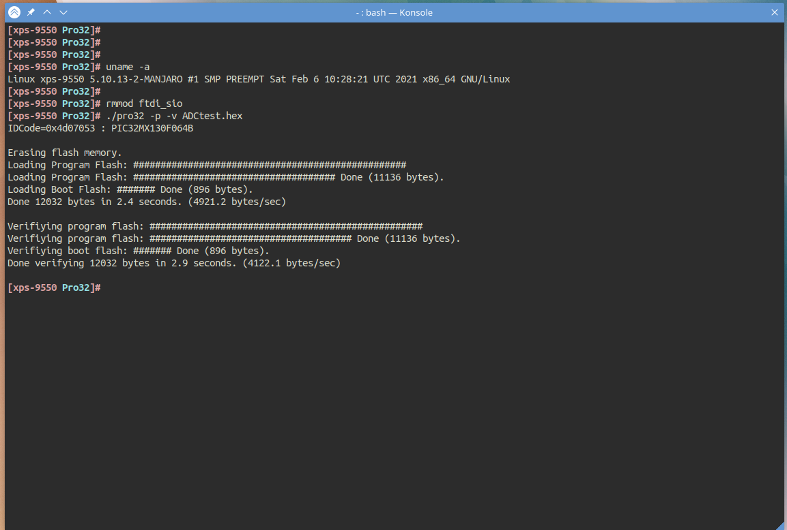
To re-enable the default driver:
$ sudo modprobe ftdi_sio
This is needed for reading anything sent over UART unfortunately.

